Model Struction

1.Attentionmodel.cpp

1.1 AttentionModel::AttentionModel(std::string& folderPath)
Explanation:
Detect the compute device (CPU or GPU).
Load a JIT-compiled PyTorch model (all_in_one.pt).
Set the model to inference mode to ensure consistent behavior.
Move the model to the appropriate device (GPU or CPU).

1.2 void AttentionModel::appendInputData(std::vector<double>& t, std::vector<int>& isArrival, std::vector<int>& isDeparture,

std::vector<int>& isFixed, std::vector<std::vector<int>>& isRuleMatched,

std::vector<std::vector<double>>& turnTime, bool newBatch)
(A) Receives multiple input parameters, all of which are std::vector of the C++ standard library:
t: Flight time (timestamp of flight arrival/departure).
isArrival: Indicates whether the flight is an arrival flight (1 for yes, 0 for no).
isDeparture: Indicates whether the flight is a departure flight (1 for yes, 0 for no).
isFixed: Whether it is a fixed flight (1 for fixed, 0 for adjustable).
isRuleMatched: A two-dimensional array indicating whether the flight matches certain rules.
turnTime: Turnaround time of the flight (i.e. the time from landing to taking off again).
newBatch: If true, the current input data is used as a new batch, otherwise it is appended to _input.
(B) Convert input data to PyTorch tensor:
t/isArrival/isDeparture/isFixed: Convert to PyTorch tensor, add one dimension to the last dimension, turn into a two-dimensional column vector, and change the shape from [N] to [N, 1].
isRuleMatched: Create an n × m integer tensor accessor_isRuleMatched with all 0s, n is the number of flights, m is the number of rules, and convert the numerical data in isRuleMatched to tensor data and fill it into accessor_isRuleMatched accordingly.
turnTime: Create an n × m integer tensor accessor_turnTime with all 0s, n is the number of flights, m is the connection time, and convert the numerical data in turnTime to tensor data and fill it into accessor_turnTime accordingly.
newBatch: If true, the current input data is used as a new batch, otherwise it is appended to _input.
(C) Normalized data:
Calculate the maximum and minimum values ​​of t (flight time) and turnTime (turnaround time) for normalization.
scale = std::max(t_max - t_min, 10 * turnTime_max)

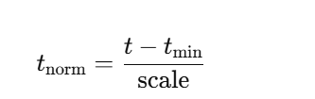
(D) Concatenate all input data:
torch::cat(..., 1): Concatenate all tensors in the second dimension (columns) to form a large matrix of [N, d], and the generated new data shape is [N, d], where d is the total number of all features.

1.3 void AttentionModel::forward(std::vector<std::vector<int>>& sol)
Data flow:

Input: _input (processed feature data).
Forward reasoning: Call the PyTorch JIT-compiled model _all_in_one for forward propagation.
Type conversion: Convert the PyTorch float type tensor to int type.
Data extraction: Traverse the tensor and store the result in std::vector<std::vector<int>> sol.

1.4 void AttentionModel::solveByBatch(std::vector<PaddingDATA*>& pdDataBatch)
This code implements the AttentionModel::solveByBatch method, which processes PaddingDATA data in batches and optimizes flight scheduling through the neural network model _all_in_one.
Its core logic is:
1.Extract data by block and convert it into a format suitable for neural networks.
2.Call the forward method to perform model inference and obtain the optimized flight scheduling plan.
3.Update the PaddingDATA object and continue to process the unfinished data until all data is processed.

2.Padding.cpp

2.1 void SrmModel::checkPtFiles()
This function checks whether the machine learning padding model (MLPaddingModel) is enabled and whether the .pt file required by the function exists:

1. If MLPaddingModel is not enabled, return directly.
2. If solvePaddingModelOpt is closed, MLPaddingModel is also disabled and returned.
3. Iterate through ptNames and check whether the .pt files exist one by one:
3.1 If the file does not exist, disable useMLPaddingModel and log a warning.
3.2 If the file exists, log that the file has been successfully read.

2.2 void SrmModel::collectPaddingDataForML(PaddingDATA& pdData, bool sortByT) const
The core functions of this function:
1.Traverse flights (arrival, departure), maintenance events, aircraft availability, and extract information such as event time, whether the rules are matched, and transfer time.
2.Use MGT Rule Manager to check whether the flight matches the rules and store the results to avoid repeated calculations.
3.Sort by time (optional) and fill in virtual events to ensure that the data structure conforms to the input format of machine learning.

2.3 void SrmModel::paddingByML()
Core functions
1. Traverse different device types
2. Traverse different sites
3. Collect event data
4. Preprocess padding data
5. Call deep learning model (batch or single calculation)

Key logic
1. Data filtering
Skip when site event data volume < 50.
Update the maximum mlMaxMgtRuleSize.

2. Padding data processing
Call collectPaddingDataForML() to preprocess data.
Use getSize() to classify data.

3. Deep learning calculation
Use AttentionModel for calculation.
Prioritize batch calculation to reduce the number of model calls and improve efficiency.

3.Model framework diagram

3.1 SRM_model
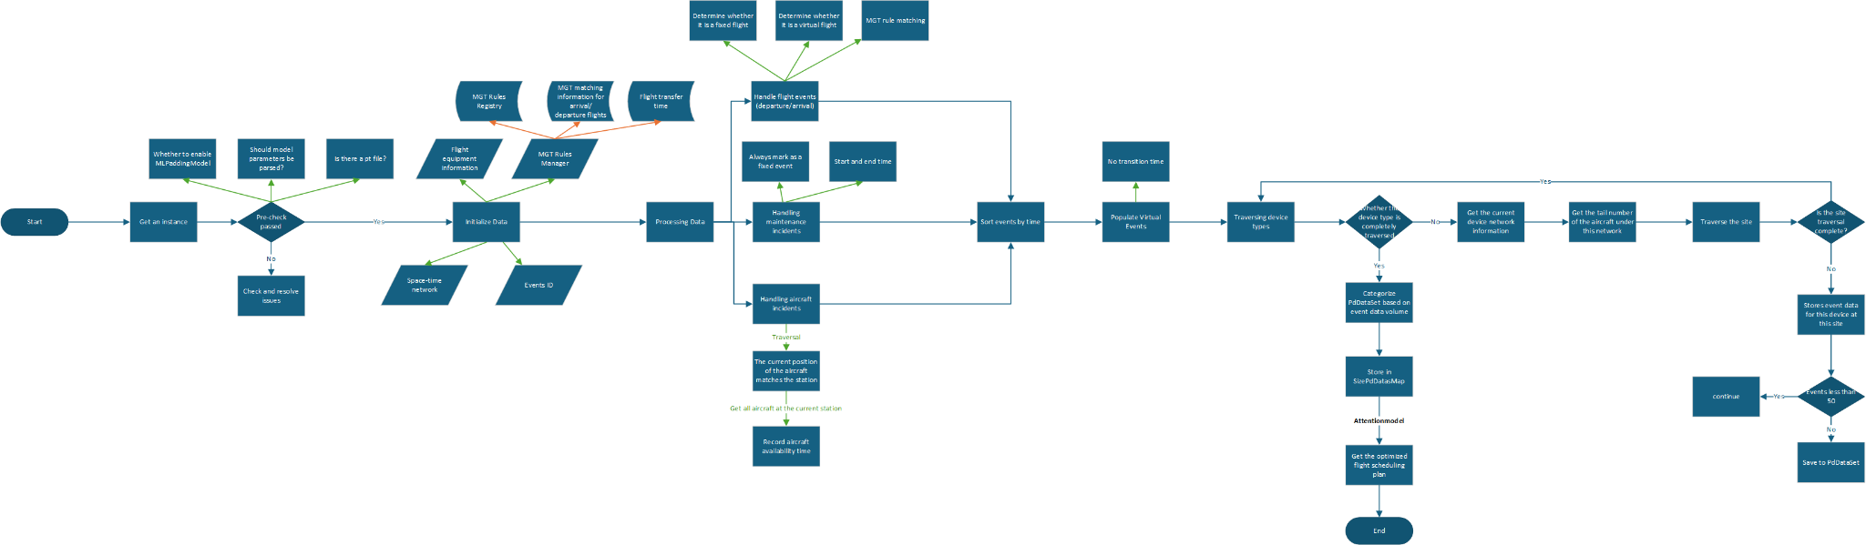

3.2 Attentionmodel
